**INTI International College Penang School of Engineering and Technology**

**3+0 Bachelor of Science (Hons) in Computer Science, in collaboration with Coventry University, UK**

**3+0 Bachelor of Science (Hons) in Computing, in collaboration with Coventry University, UK**

**Coursework cover sheet**

**Section A - To be completed by the student**

|  |  |
| --- | --- |
| Full Name: MAH CHUN-HOE | |
| CU Student ID Number: | |
| Semester: 1 | |
| Session:  **August 2022** | |
| Lecturer:  **Nadhrah Abdul Hadi (nadhrah.abdulhadi@newinti.edu.my)** | |
| Module Code and Title:  **4067CEM Software Design** | |
| Assignment No. / Title:  **Continuous Assessment** | % of Module Mark:  **50** |
| Hand out Date:  **6th September 2022** | Due Date:  **Task 1: 30 September 2022, by 11.59pm.**  **Task 2: 18 November 2022, by 11.59pm**  **Task 3: 4 November 2022, by 11.59pm.**  **Task 4: 4 November 2022, by 11.59pm.**  **Task 5: 4 November 2022, by 11.59pm.** |
| Penalties: No late work will be accepted. If you are unable to submit coursework on time due to extenuating circumstances, you may be eligible for an extension. Please consult the lecturer. | |
| Declaration: I/we the undersigned confirm that I/we have read and agree to abide by the University regulations on plagiarism and cheating and Faculty coursework policies and procedures. I/we confirm that this piece of work is my/our own. I/we consent to appropriate storage of our work for plagiarism checking.  Signature(s): ________________________ | |

**Section B - To be completed by the module leader**

|  |  |  |
| --- | --- | --- |
| Intended learning outcomes assessed by this work:  1. Understand and apply appropriate concepts, tools and techniques to each stage of the software development  2. Understand and apply design patterns to software components in developing new software  3. Demonstrate an understanding of project planning and working to agreed deadlines, along with professional, interpersonal skills and effective communication required for software production  5. Demonstrate an awareness of, and ability to apply, social, professional, legal and ethical standards as documented in relevant laws and professional codes of conduct such as that of the Malaysian National Computer Confederation. | | |
| Marking scheme | Max | Mark |
| 1. User Story Mapping 2. Setting up a GitHub Repository 3. Creating a Class diagram and design pattern selection 4. Creating a Prototype User Interface and Usability Testing 5. Discuss the ethical issue related to the software | 20  10  30  20  20 |  |
| Total | 100 |  |

**The 4067CEM assessment should be completed as a full individual work over the course of the module. The assessment output are only judged at the end of the module and not by the expectations during that week. The assessment should be undertaken individually. All submissions will be checked against each other and the internet for possible plagiarism.**

Activities – These activities consists of **50%** of your coursework marks. It will be run throughout the semester and there will be a final submission at the end of the semester. These activities consists of activities that will be done in a software design phase.

# System

College Buddy System for Students.

# Task 1 – User Story Mapping (20 marks)

The first thing that you need to do is ask the user what they wished for in a system. The user here can be your friends as the system is related to them. Get at least 10 real users to get their feedback. Document their feedback. Use software like Miro to complete this activity.

Output – All the user stories, backlog with goals, activities and tasks. In Word format, uploaded to GitHub.

Due – Week 6 of the semester. 30 September 2022, by 11.59pm.

# Task 2 – Setting up a GitHub Repository (10 marks)

This is where the output of the tasks will be stored, Make sure you register an account, create a repository and your files are uploaded here and it is in an organized manner and can be easily found.

Output – GitHub Repository with Task 1, Task 3, Task 4 and Task 5 documents. Take note the date of the files will be shown so you must follow the due date of each task.

Due – It will be accessed at Week 13 of the semester. 18 November 2022, by 11.59pm

# Task 3 – Creating a Class diagram and design pattern selection (30 marks)

Create a simple Class diagram which should consists of the Classes that might be used to represent the system and the association between them. You don’t have to declare the attributes and operations for this activity. You do have to explain the class responsibility of each class declared. You can use software like StarUML to complete this activity.

Output – A class diagram containing classes and associations. In Word format, uploaded to GitHub.

Consider the problem and select a suitable design pattern that can be implemented on the problem. Give justification on why the design pattern was chosen. Draw the UML diagram representing your class diagram as a design pattern UML. Include all the abstract class/interface, concrete class and inheritance (if any) used to represent the problem.

Output – UML diagram representing the design pattern. In Word format, uploaded to GitHub.

Due – Week 11 of the semester. 4 November 2022, by 11.59pm.

# Task 4 – Creating a Prototype User Interface and Usability Testing (20 marks)

Create a Prototype User Interface (hand drawn/digital) of TWO (2) important functions of the proposed system. Come up with a usability testing questions. You don’t have to carry out the test, just prepare the questions. You should indicate what you are testing for in the Usability Testing.

Output – A Prototype and Usability Testing Questions. In Word format, uploaded to GitHub.

Due – Week 11 of the semester. 4 November 2022, by 11.59pm.

# Task 5 – Discuss the ethical issue related to the software (20 marks)

Discuss and do a critical analysis of your software in this areas, privacy concerns, intellectual property rights and effects on the society.

Output – A report in Word format, uploaded to GitHub.

Due – Week 11 of the semester. 4 November 2022, by 11.59pm.

# Submission

All tasks needed to be documented in Word format and submitted for SafeAssign checking (Links will be provided before the due date).

Upload the document and the SafeAssign report to your GitHub repository by each task due date.

Due – It will be accessed at Week 13 of the semester. 18 November 2022, by 11.59pm

**Marking Rubric for Continuous Assessment**

|  |  |  |  |  |  |
| --- | --- | --- | --- | --- | --- |
|  | **Marks Below 40%** | **Marks in the range 40 – 49%** | **Marks in the range**  **50 – 59%** | **Marks in the range 60 – 69%** | **Marks 70% and above** |
| **User Story**  **Mapping**  **(20 marks)** | User Story Mapping not done or User Story copied/does not match the exact system. | User Story Mapping done at a minimum level and does not capture the important activities of the system. | User Story Mapping done and does capture several important activities of the system. The breakdown of the user story mapping can be improved. | User Story Mapping done and does capture several important activities of the system. The breakdown of the user story mapping is good and uses software that can assist that process (For example Miro compared to Ms. Word). | User Story Mapping done and does capture most important activities of the system. The breakdown of the  user story mapping is excellent and uses  software that can assist that process (For example Miro  compared to Ms.  Word). |
| **Setting up a**  **GitHub**  **Repository**  **(10 marks)** | GitHub repository does not exist or cannot be accessed or the required files are not available at the time of access. | GitHub repository exist and some of the required files are not available at the time of access. | GitHub repository exist and most of the required files are available at the time of access. However the dates does not follow the required deadline. | GitHub repository exist and all of the required files are available at the time of access. However the dates for some files does not follow the required deadline. | GitHub repository exist and all of the required files are available at the time of access. The dates on the files follows the required deadline. |
| **Creating a Class diagram and design pattern selection**  **(30 marks)** | The Class diagram does not represent the required solution (contains generic or non- related classes such as admin), the design pattern suggested is not suitable for the given problem. | The Class diagram and design pattern represent the required solution but in a very general and incomplete way. Required classes in the design are not declared. | The Class diagram and design pattern represent the required solution in a partial way. A few required classes in the design are not declared. | The Class diagram and design pattern represent the required solution in a satisfactory way. Most required classes are declared. | The Class diagram and design pattern represent the required solution in an excellent way. All required classes are declared. |
| **Creating a**  **Prototype User**  **Interface and**  **Usability Testing**  **(20 marks)** | No prototype were available or the measurement for the usability testing is not clear. | The prototype cover minimalist and trivial design (such as login) and the measurements for the usability testing are not clear. | The prototype cover adequate design and several measurements for the usability testing are not clear. | The prototype cover good design and most measurements for the usability testing are clear. | The prototype cover excellent design and all measurements for the usability testing are clear. |
| **Discuss the**  **ethical issue**  **related to the**  **software**  **(20 marks)** | There is no discussion on the ethical issue or only the theories are pasted back for this component. | There is an attempt to discuss on the ethical issue but no critical  analysis was done | There is an attempt to discuss on the ethical issue with some critical  analysis was done | There is an attempt to discuss on the ethical issue with good critical analysis. | There is an attempt to discuss on the ethical issue with excellent critical analysis. |

**Task 1 – User Story Mapping**

**College Buddy System for Students**

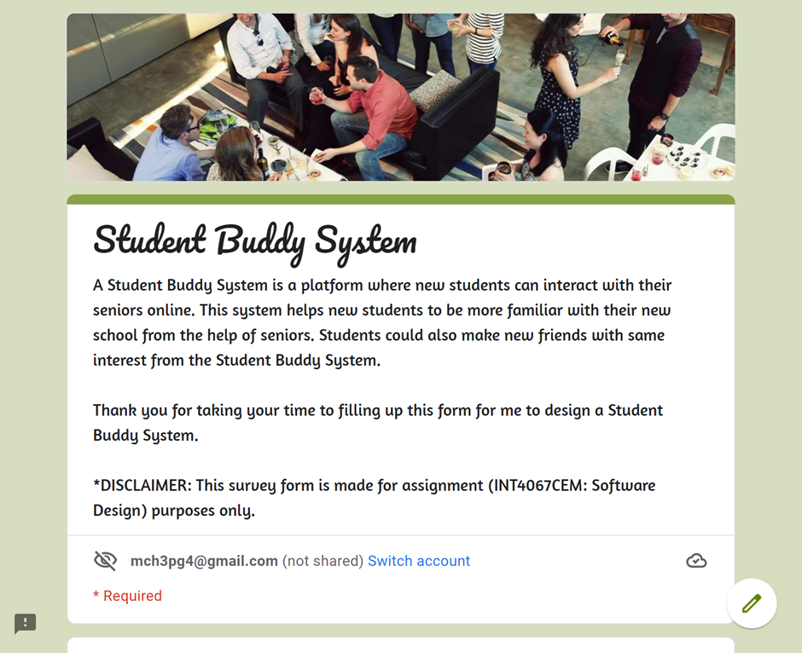A Student Buddy System is a platform where new students can interact with many of their seniors and also course mates online. This system helps new students to be more familiar with their new school from the help of seniors. Seniors can introduce freshmen to everything happening around the school, the facilities, the clubs or societies available and many more. Seniors can also help out with their studies if they need any. This system promotes the school to become a more inclusive environment for everyone from different backgrounds. International students will benefit from this system the most as they are miles away from home. Seniors will learn to take on responsibility in guiding the new students, while freshmen know that they will have someone they can trust whenever they come across any obstacles. With this system, freshmen can learn a lot of thinking skills or problem-solving skills as they interact with their seniors. This is vital for them as they can apply these skills when they are in the industry. The Student Buddy System will deeply change the school into a more welcoming, interactive and sociable environment for all, without losing out the minorities.

Figure 1: Student Buddy System Survey Form

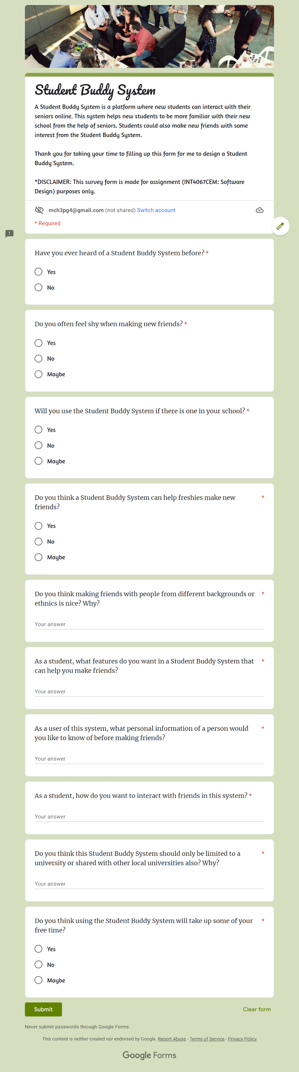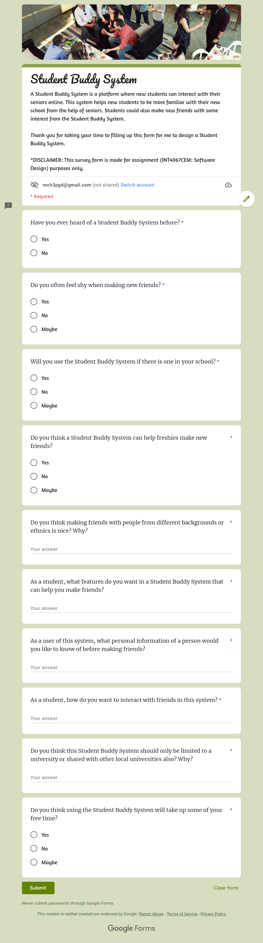Figure 2: Student Buddy System Survey Form

Figure 3: Student Buddy System Survey Form

Figure 4: Student Buddy System Survey Form

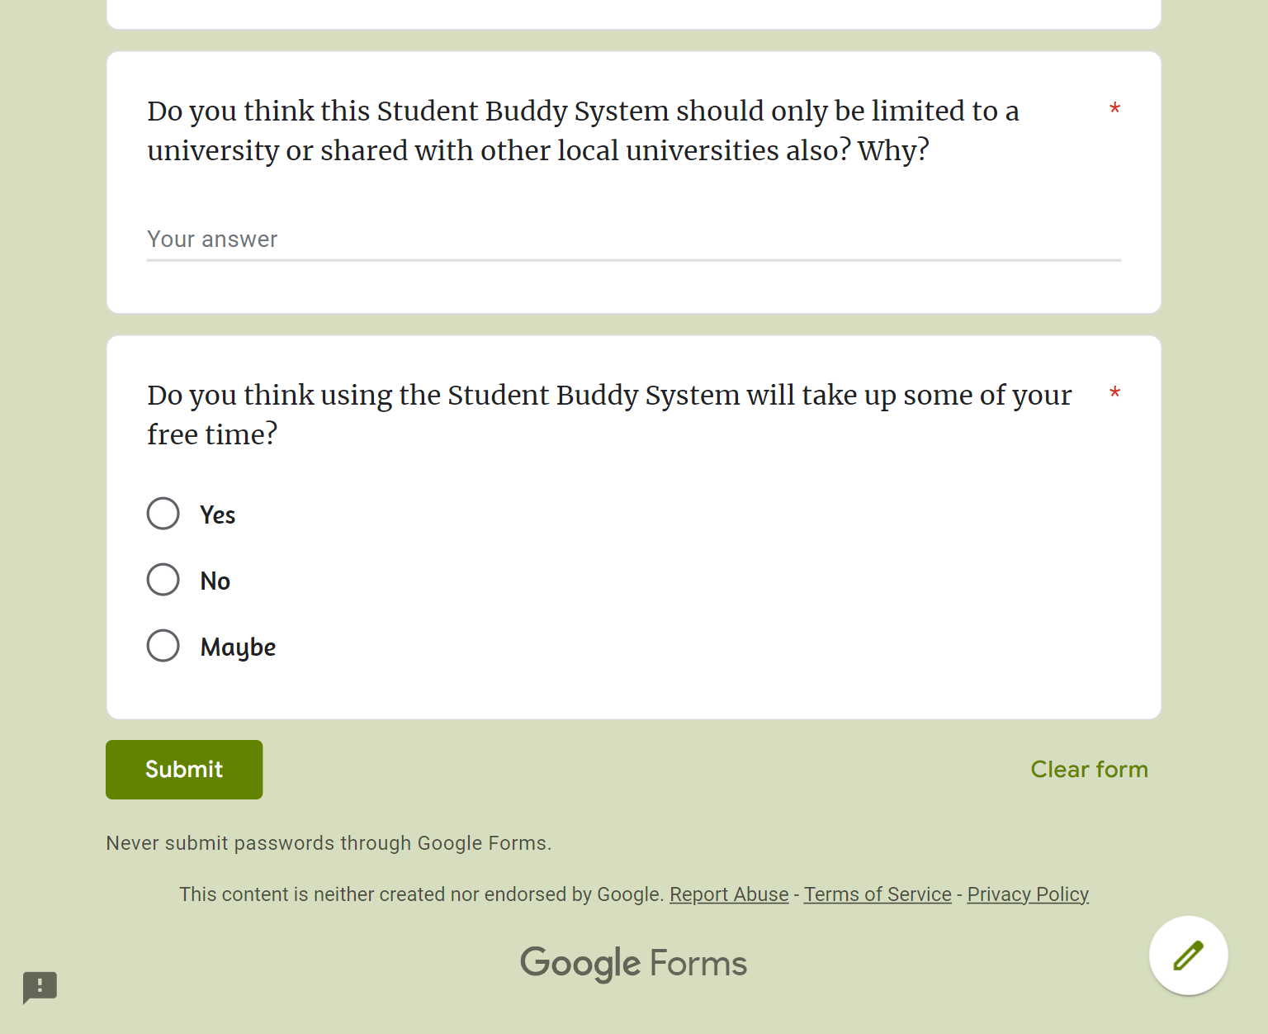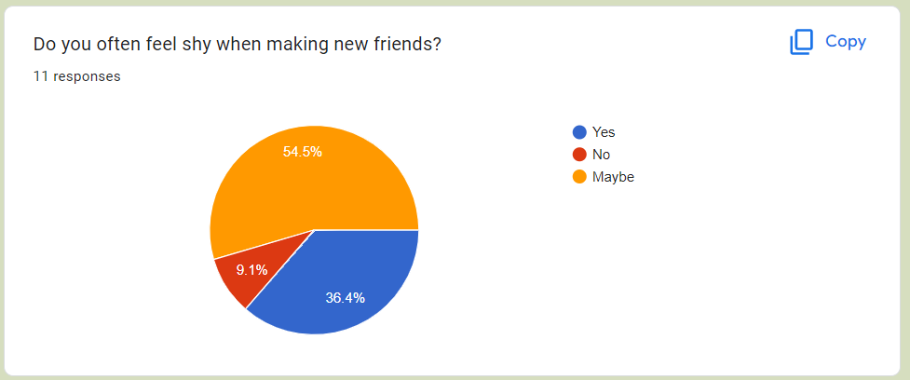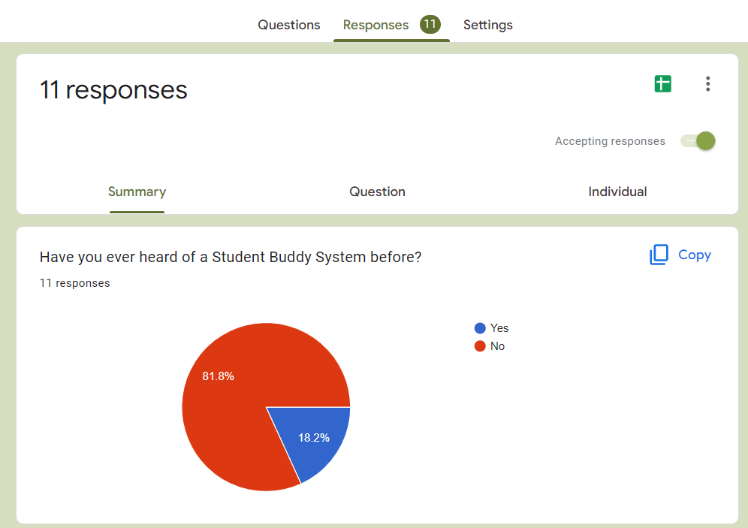

Figure 5: Student Buddy System Survey Responses

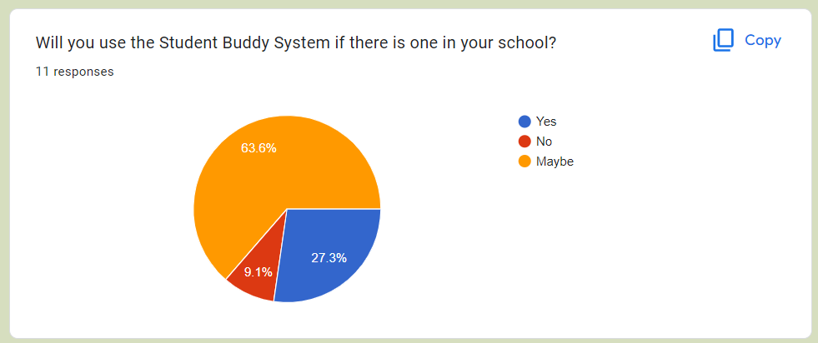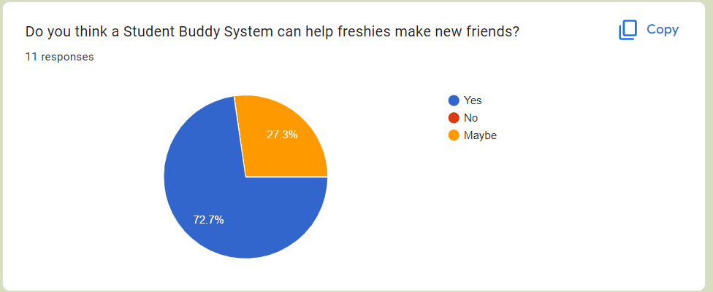

Figure 6: Student Buddy System Survey Responses

Figure 7: Student Buddy System Survey Responses

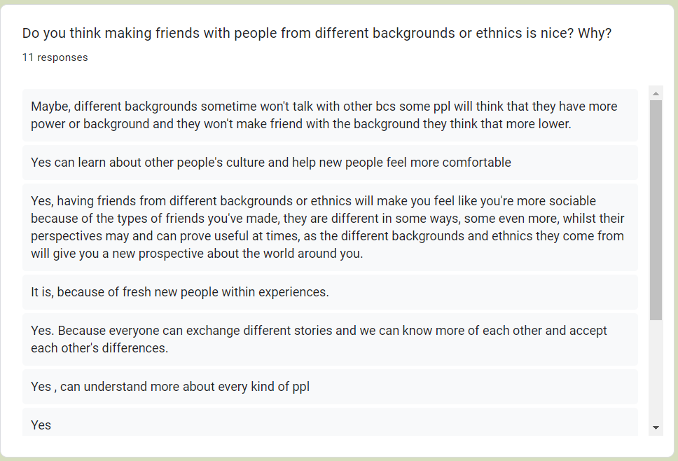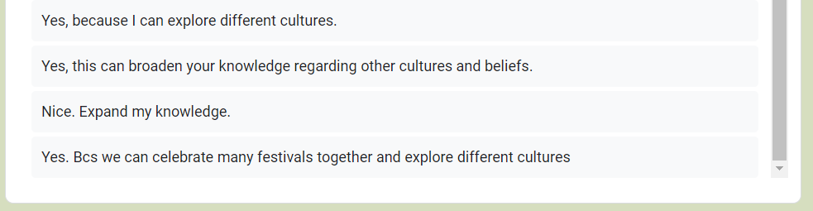

Figure 8: Student Buddy System Survey Responses

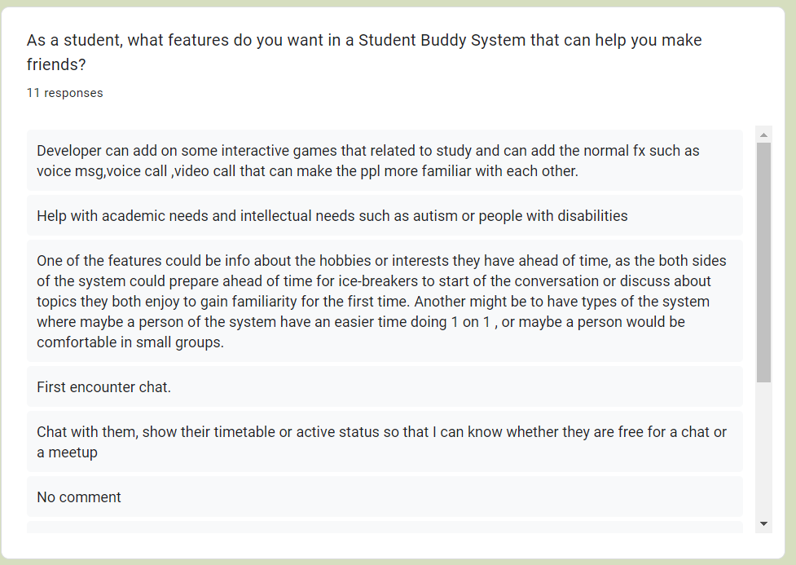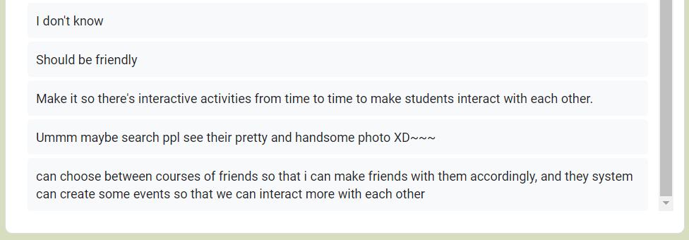

Figure 9: Student Buddy System Survey Responses

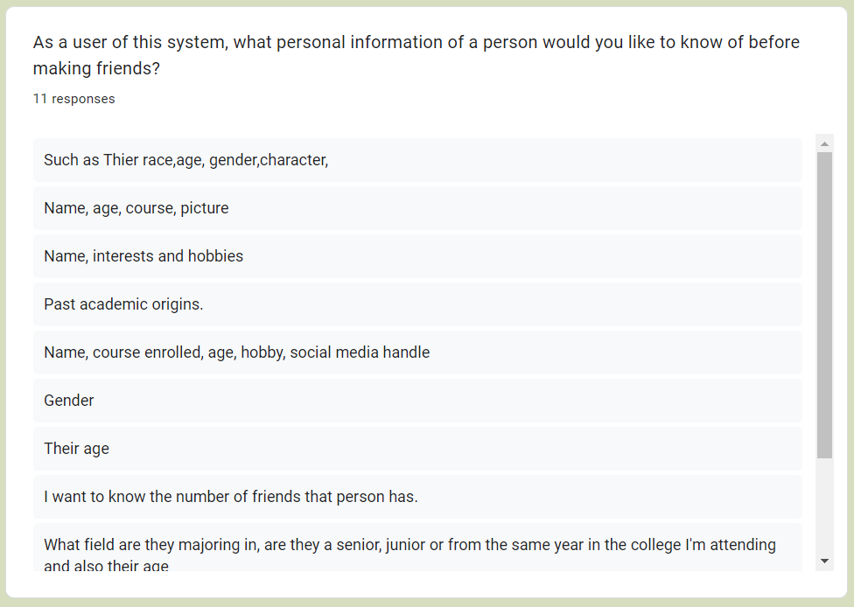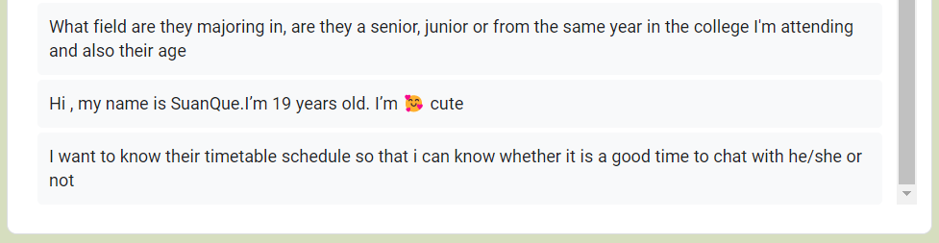

Figure 10: Student Buddy System Survey Responses

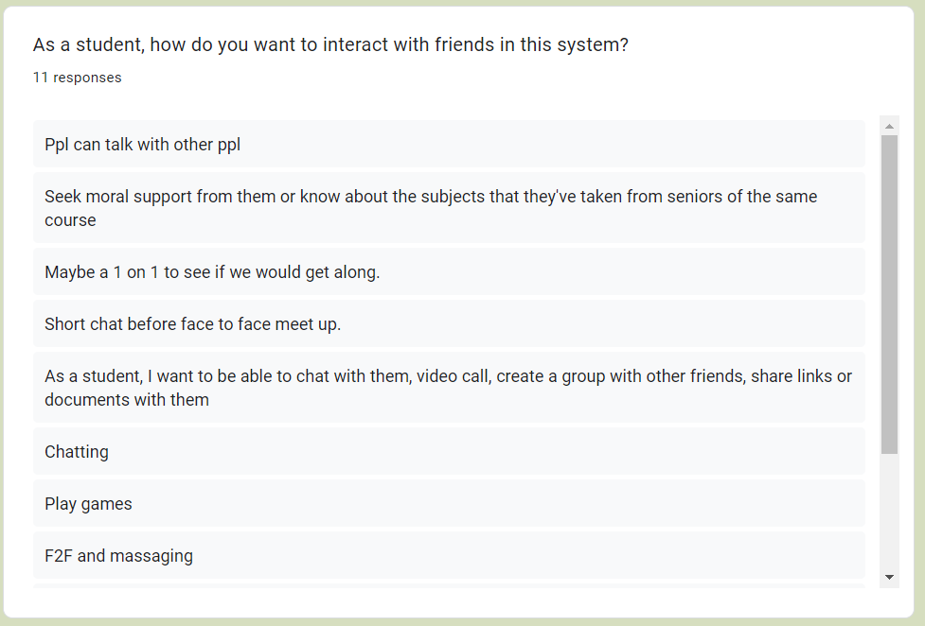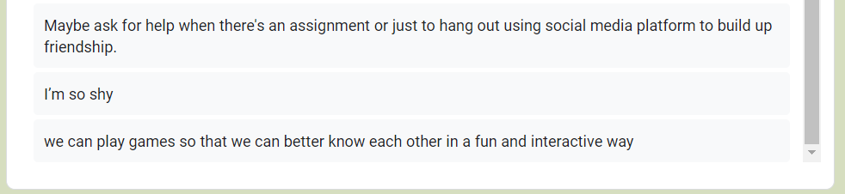

Figure 11: Student Buddy System Survey Responses

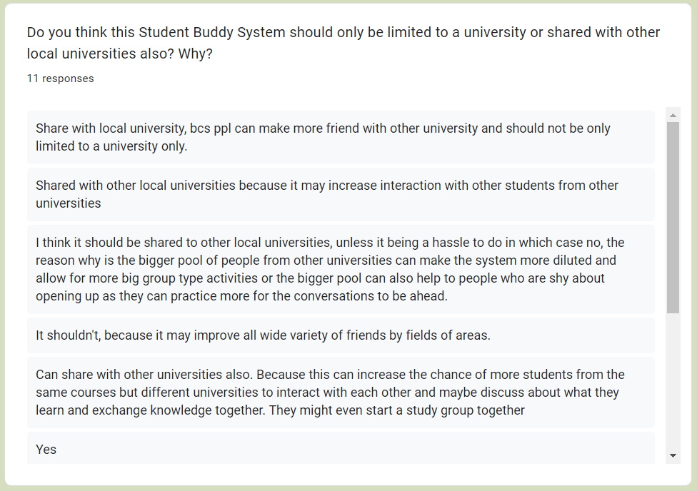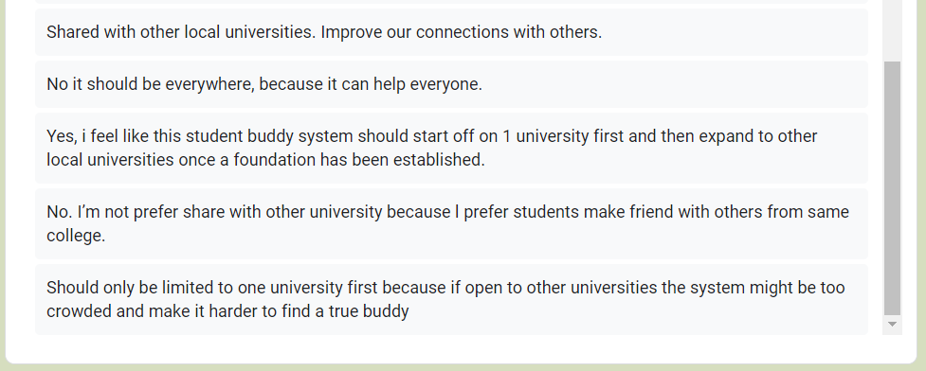

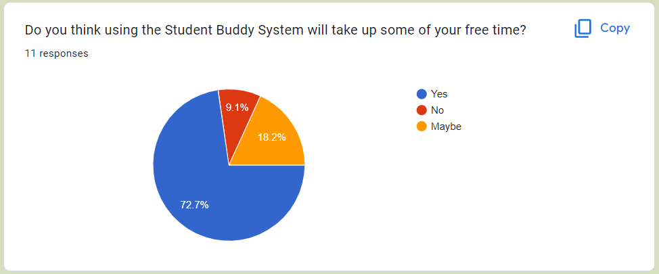

Figure 12: Student Buddy System Survey Responses

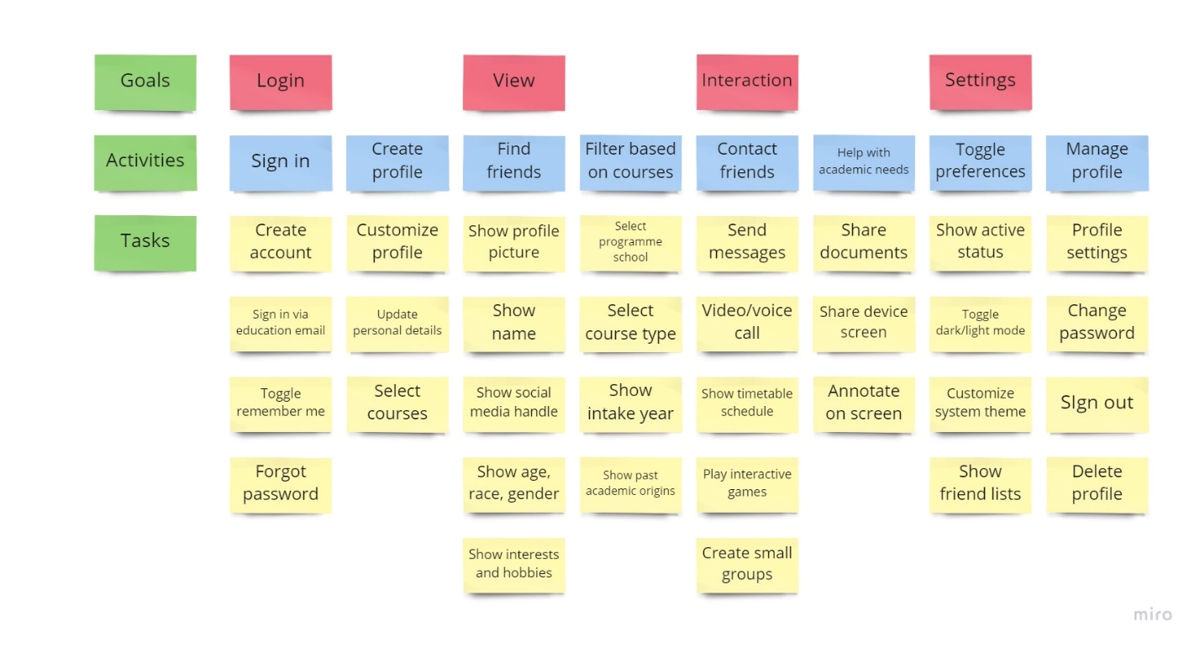

Figure 13: User Story Mapping for Student Buddy System (User is Students)